
Module 4: Cornerstones of Peer Support – Participant Handbook

Information from Module 4 Slides: 2
Self-Care Plans 3
Homework to be submitted before Module 5: 4

Information from Module 4 Slides:
Self-Awareness is a deep understanding of who you are; a sense of knowing who you are – including your history, experiences, values, preferences, and limits. Self awareness involves tuning into yourself, becoming acquainted with yourself, understanding yourself, forgiving yourself, loving yourself for who you are and who you want to be.
Self Responsibility is being accountable for one’s self or taking charge of one’s self. Self responsibility includes self discipline and self management.
Self care involves a willingness to extend the same compassion to yourself as you do to others. Self care includes a commitment to nurturing your physical, emotional, mental and spiritual being. Self care involves a deep knowing of your priorities as well as your limits; a willingness to take actions that demonstrates your commitment to yourself.
Supports include people, places, activities and things. Support is a key ingredient in life, personal journeys, and peer support. The reciprocity of peer support includes receiving as well as giving support.

Methods to Combat Isolation
- Reach out to family and friends.
- Join a club or a community.
- Get a pet, volunteer at a shelter, or offer to walk a friend’s pet.
- Stay active and go outdoors.
- Start a project or craft.

Self-Care Plans
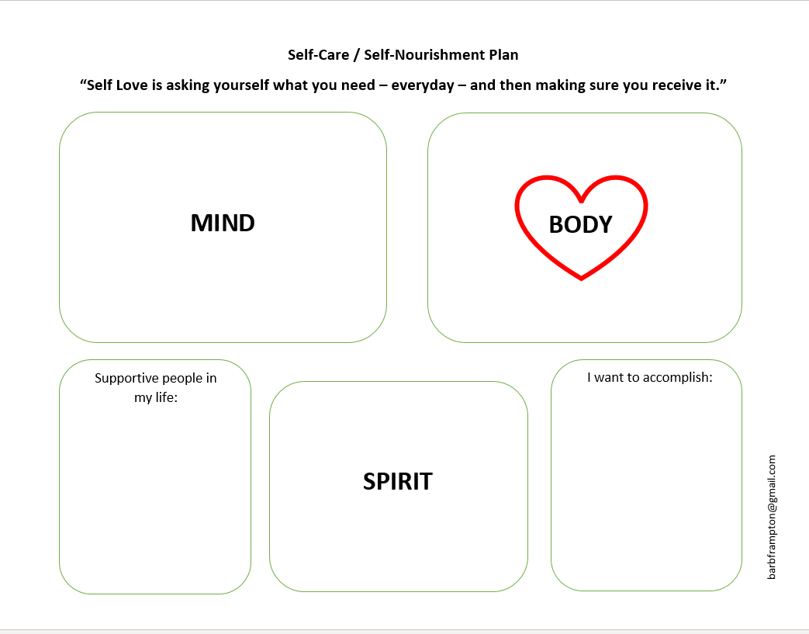
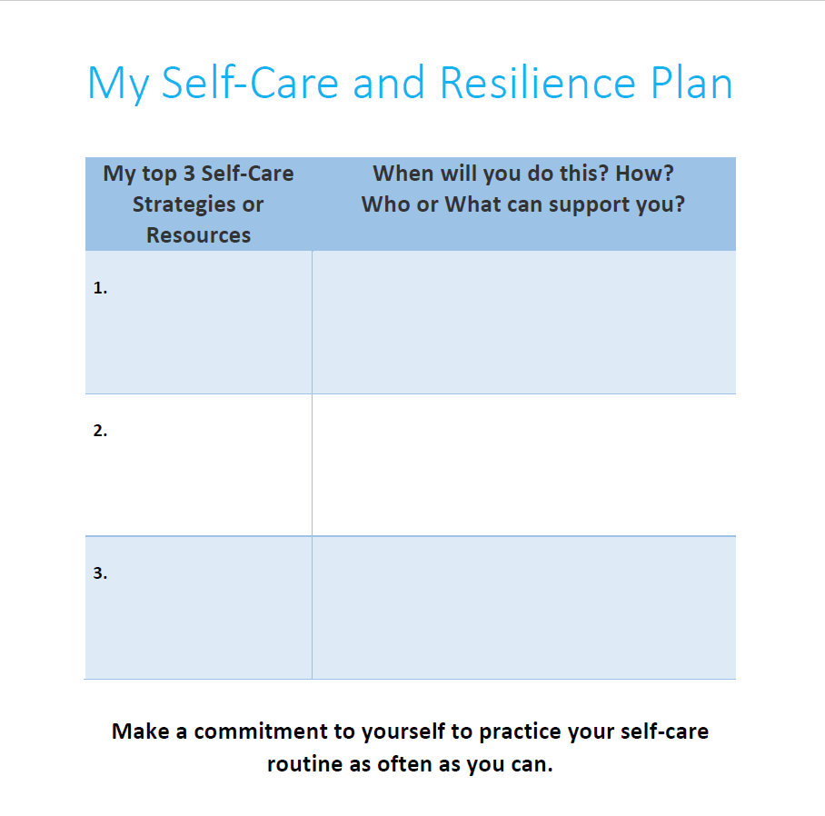

Homework to be submitted before Module 5:

Should take approximately 10 to 15 minutes.

Reflection: Describe what you believe is your strongest cornerstone as well as the cornerstone that you intend to further invest in developing. How will you do this?

Please e-mail your response to [Training Coordinator] at [email@peerworks.ca] with the subject line “Your Name Self-Awareness Reflection.” e.g. “Allyson Self-Awareness Reflection.

You can send your response in the body of the email or attach your response as a Word document and name it “Your Name Self-Awareness Reflection.” E.g. “Allyson Self-Awareness Reflection.doc”

